Lab - Task Manager in Windows 7 and Vista
- Introduction
In this lab, you will explore Task Manager and manage processes from within Task Manager.
- Recommended Equipment
The following equipment is required for this exercise:
- A computer running Windows 7 or Vista
  - Work in the Applications Tab of Windows Task Manager.
    - Log on to Windows as an administrator.
    - Open a browser and a folder.
    - Click the desktop and press Ctrl-Alt-Delete > Start Task Manager > Applications tab.
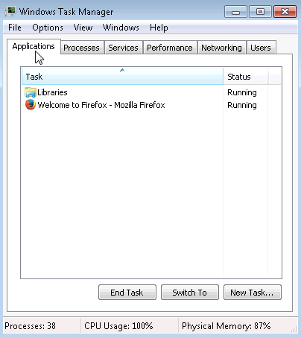
    - Select the open browser and then click Switch To.
What happened to the browser?

    - Bring Windows Task Manager to the front of the desktop. Click New Task to open the Create New Task window.
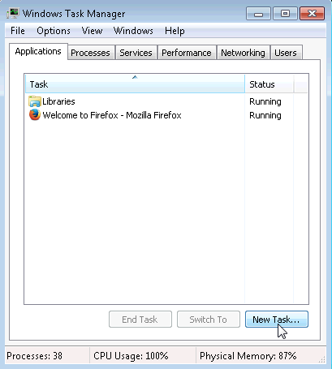
    - In the Open field, type Notepad and click OK.
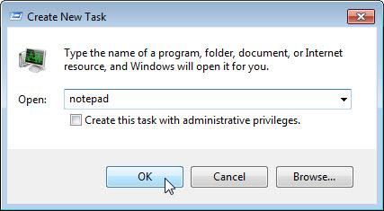
What happens?

    - Navigate back to the Windows Task Manager, select Notepad, and click End Task.
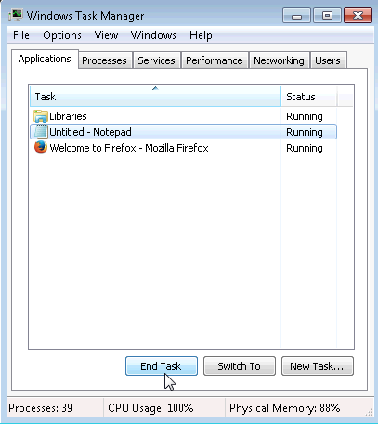
What happens?

  - Work in the Services tab of Windows Task Manager.
    - Click the Services tab. Use the scroll bar on the right of the Services window to view all the services listed
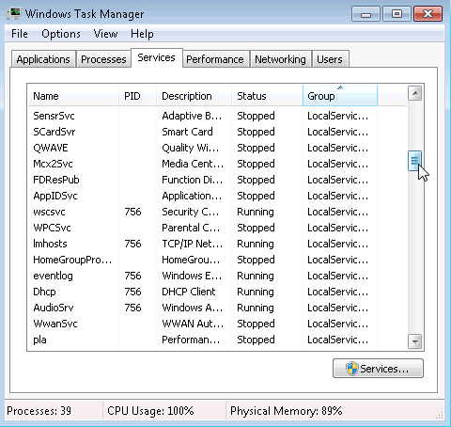
What are the statuses listed?

  - Work in the Performance tab of Windows Task Manager.
    - Click the Performance tab.
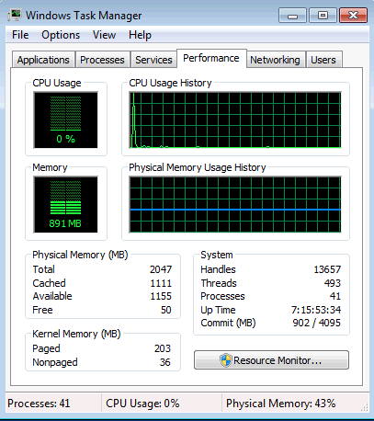
How many threads are running?
____________________________________________________________________________________
How many processes are running?
____________________________________________________________________________________
What is the total physical memory (MB)?
____________________________________________________________________________________
What is the available physical memory (MB)?
____________________________________________________________________________________
How much physical memory (MB) is being used by the system?
____________________________________________________________________________________
  - Work in the Networking tab of Windows Task Manager.
    - Click the Networking tab.
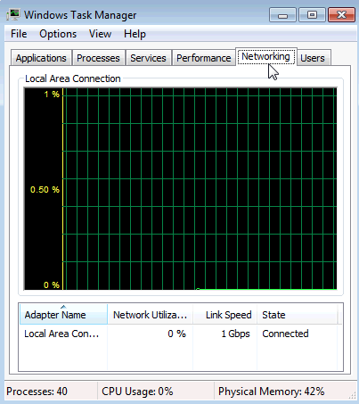
What is the link speed?
____________________________________________________________________________________
  - Work in the Users tab of Windows Task Manager.
    - Click the Users tab.
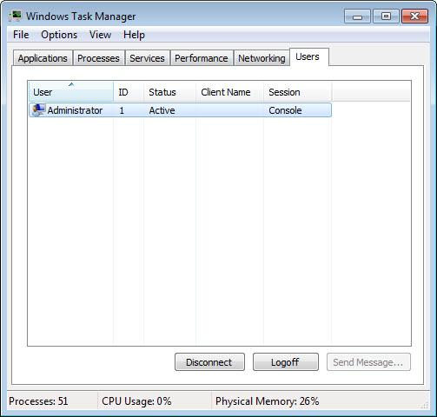
List all users and their status.
____________________________________________________________________________________
What actions can you perform on the user from this window?
____________________________________________________________________________________
  - Work in the Processes tab of Windows Task Manager.
    - Click the Processes tab.
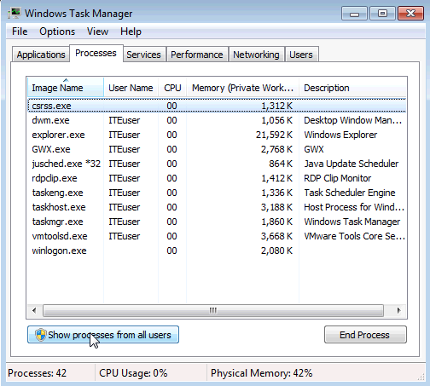
    - Check the checkbox Show processes from all users.
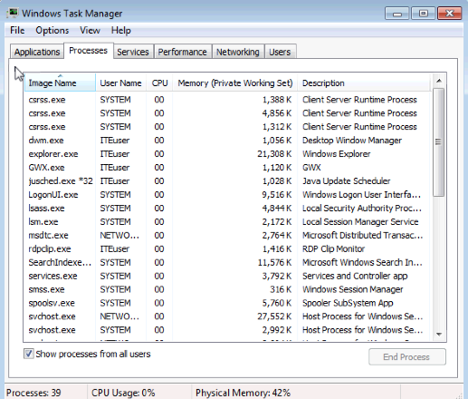
    - Double-click the white border around the Processes tab. This changes the view of Windows Task Manager to compact mode.
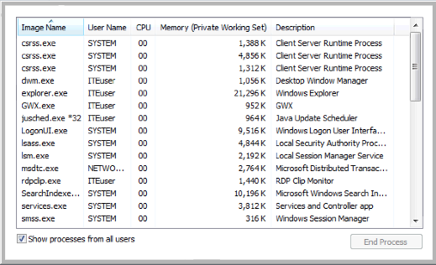
Note: The User Account Control window may open in Vista asking for permission to continue. Click Continue.
    - Click the heading Image Name. Click Image Name again.
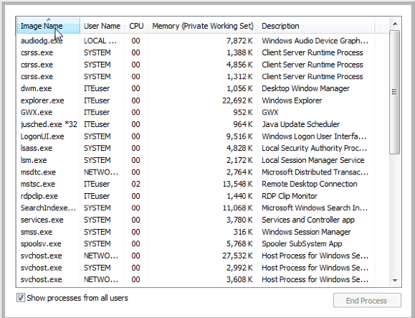
What effect does this have on the columns?
____________________________________________________________________________________
    - Click Memory (Private Working Set).
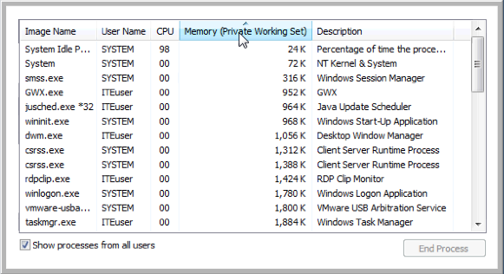
What affect does this have on the columns?
____________________________________________________________________________________
    - Double-click the outside border again to return to tabs mode.
    - Open a browser.
Note: Firefox is used in this lab. However, any browser will work. Just substitute your browser name whenever you see the word Firefox.
    - Return to the Windows Task Manager. Click Image Name so the list is in alphabetical order, then locate and select firefox.exe.
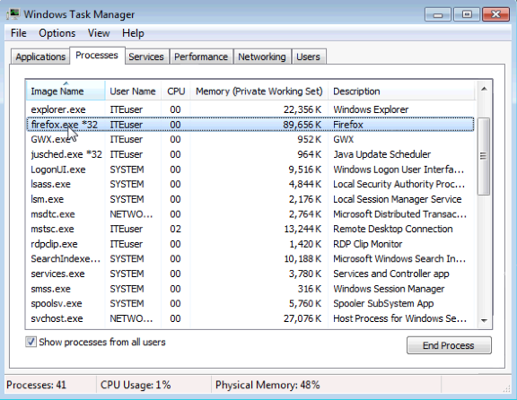
    - Right-click firefox.exe > Set Priority.
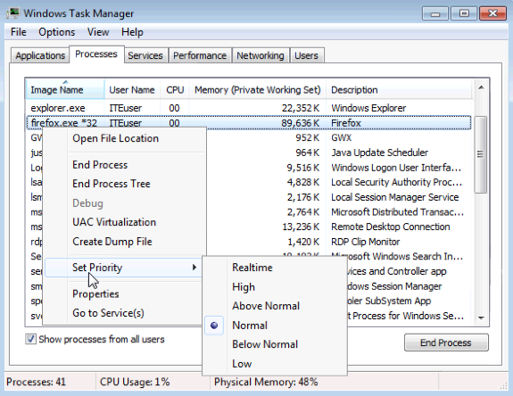
What is the default priority for the browser?
____________________________________________________________________________________
    - Set the priority to Above Normal. Then click Change priority in the Windows Task Manager warning message.
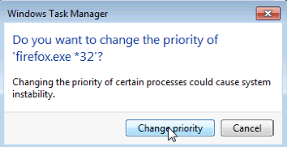
  - Change the fields that are displayed in the Windows Task Manager.
    - Click View > Select Columns.
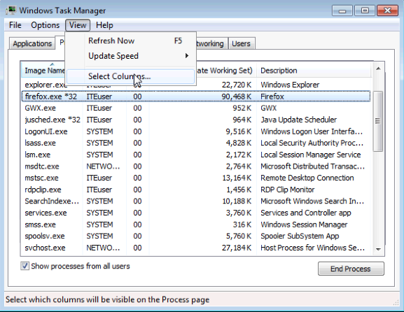
    - The Select Process Page Columns window opens. Check Base Priority and click OK.
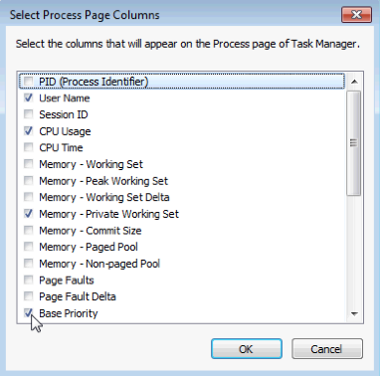
    - Expand the width of the Windows Task Manager so the Base Priority column is visible.
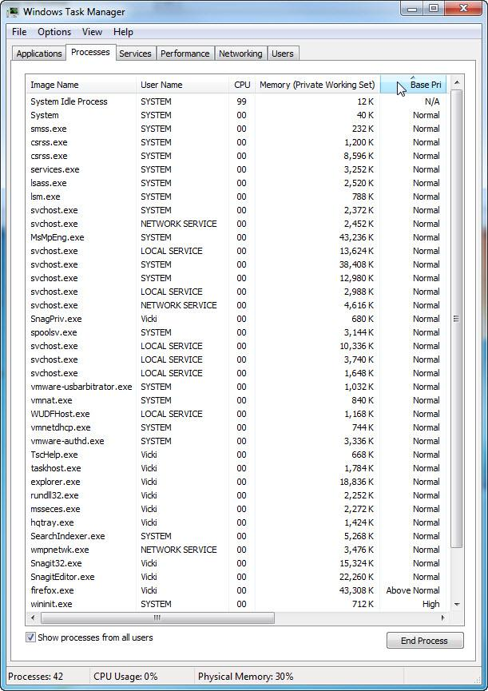
List the name of the image that has a base priority of Above Normal?
____________________________________________________________________________________
Which image name has a base priority of N/A?
____________________________________________________________________________________
    - Reset Firefox.exe base priority to normal. To do this, right-click firefox.exe > Set Priority > Normal > Change priority.
    - Click View > Select Columns. Uncheck Base Priority and click OK.
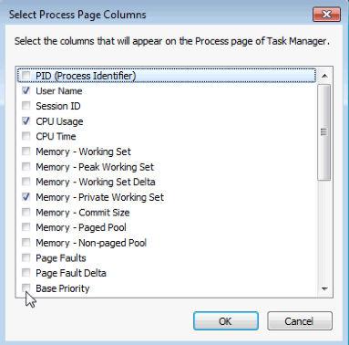
    - Close Firefox.
Is Firefox listed as a process?
____________________________________________________________________________________
    - Close all open windows.
- Reflection
Why is it important for an administrator to understand how to work within the Windows Task Manager?
_______________________________________________________________________________________
_______________________________________________________________________________________
_______________________________________________________________________________________
_______________________________________________________________________________________

